LAB TASK 5
Given Data:
Values:
scores = [3, 5, 2, 9, 0, 7]
We want a complete tree so we will add two 0 at the end
[3, 5, 2, 9, 0, 7, 0, 0]
Minimax rule
MAX picks the biggest number
MIN returns the smallest value
Diagram
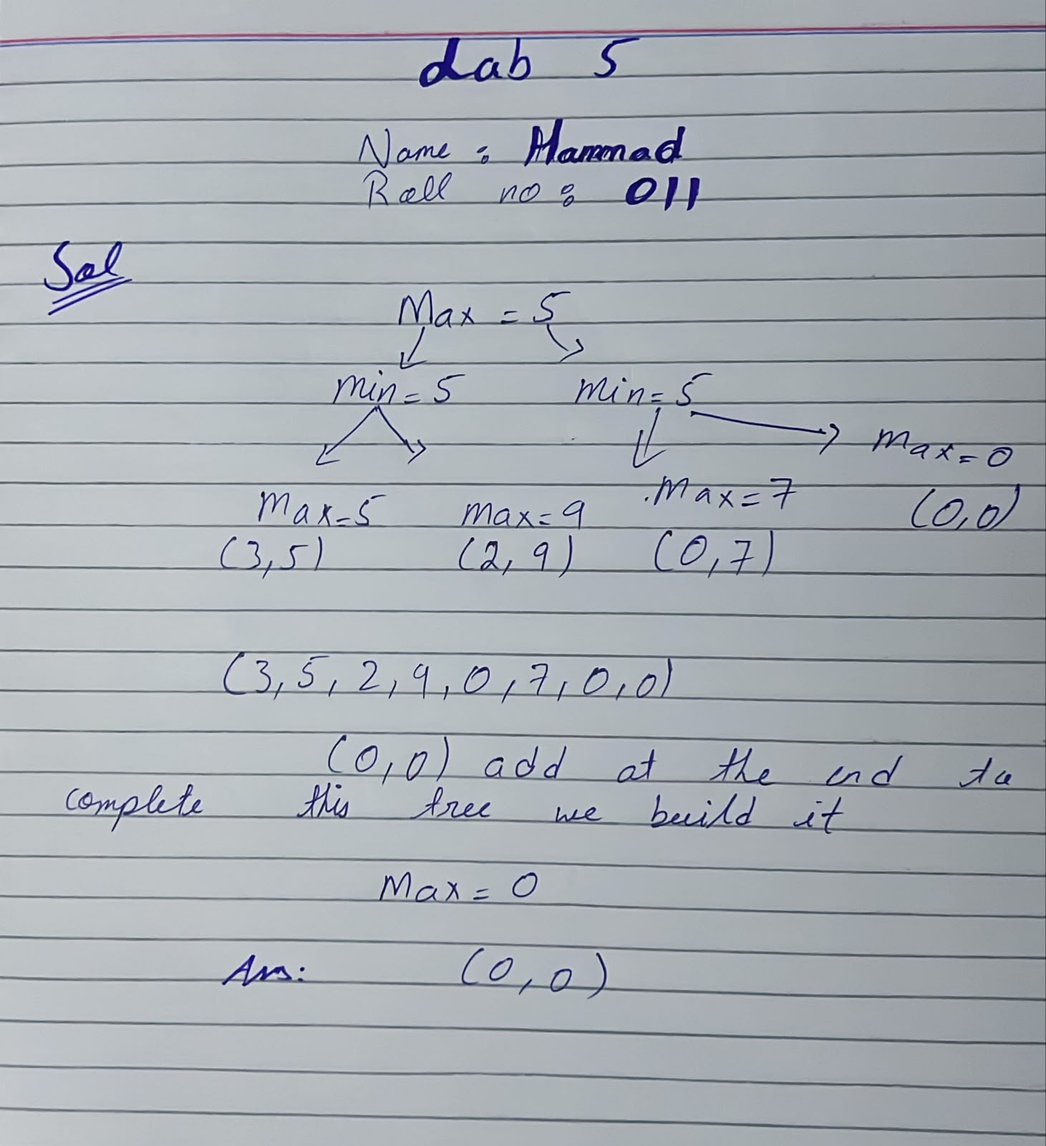
Level 1
In diagram Max chooses the largest value from pair
max(3,5)=5
max(2,9)=9
max(0,7)=7
max(0,0)=0
Level 2
In diagram MIN chooses the largest value from pair.
min(5,9)=5
min(7,0)=0
Level 3
In diagram the root MAX chooses the largest value from pair
max(5,0) = 5

